Play these games and interact with our objects and rooms. Take a picture of this game to use around the museum.

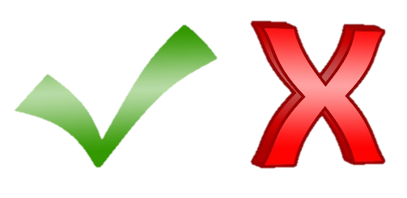
1
Yes or no?
Choose a favourite object and see if someone can it by only answering questions with a yes or a no

2
Big or small?
Give everyone 10 seconds to find the biggest or smallest object in the room. Compare objects and see who wins

3
I went to Selly Manor and found…
You start by saying ‘I went to Selly Manor and found…’ then add an object you can see. The next player says the same thing, the object you said and then adds their own object. The list goes on until someone makes a mistake or says ‘um’, then they are out.

4
Eye-spy
There are so many things inside Selly Manor you won’t run out of ideas to play Eye-spy

