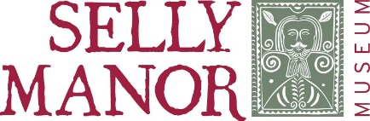
Educational Film
Booking Form

Which film package would you like to book? (please tick all that apply)
The Tudors (£60)
Great Fire of London (£60)

Your details
Name of School
Contact name
Position
Email address
Address
Post code
Telephone Number

Payment
Total cost
(£60 per film package)
Please indicate your payment method
Invoice
(please provide a name and email of the person who will deal with the invoice)
Debit / Credit Card
(please complete the payment details on page 2)

Please return this completed form to:
sellymanor@bvt.org.uk

To pay by debit or credit card, please complete this form.
If you would prefer to pay over the phone please email sellymanor@bvt.org.uk and a member of our team will arrange to call you
Debit / Credit Card
Total to pay
Name on card
Registered address
and post code
Debit / Credit Card number
Expiry date (dd/mm)
CV2
(last 3 digits on
reverse of card)
Signature
Date

Terms and conditions
- Each film package is £60 per school. You are permitted to use these films for educational purposes only by the school which purchases the package.
- Multi Academy Trusts, or multi-site organisations, must purchase a package per school site.
- The films are permitted to be used by your school pupils for home learning but must not be shared or distributed to any other individuals or organisations.
- Packages will be made available to you via a private link on the Selly Manor Museum You Tube Channel. Access will be provided once your booking has been processed, until Friday 23rd July.
- We reserve the right to revoke access if any of the above terms are breached.
- All content remains the copyright of Selly Manor Museum and Bournville Village Trust.
Thank you for your support, and we hope you
enjoy the film packages we provide.

